The EZ Toiletries CaseTM

from

Travel X©

**User Manual**

Please read this user manual for the EZ Toiletries Case before use to ensure safety proper use.

Travel X’s©

EZ Toiletries CaseTM

**Table of Contents**

Assembly                                        3

Use and Maintenance                                    4

Part Maintenance/Recommendations                            5

Warranty Information                                     6

Service Center Information                                 7

**Assembly**

Thanks to the “EZ” technology, the EZ Toiletries Case™ comes pre-assembled, and is ready to use right out of the box for easy customer convenience! It is composed of four parts, seen in the picture below.

Each case is comprised of a top case, a bottom case, a stand, and a pin.

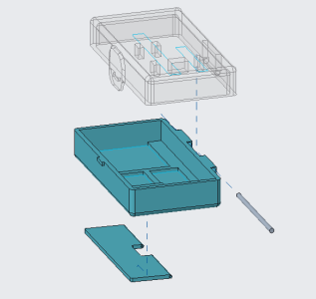

**Use and Maintenance**

The easy-to-use design of the EZ Toiletries Case™ makes for simple use. The case comes with built-in components for a toothbrush, comb, razor, floss, and travel-size deodorant (not included with case). The stand located at the bottom of the case can be extended to ensure all components stay clean, dry, and out of the way. The cases latch creates a watertight seal around the edge as well for any unforeseen spills. The case should only be placed on flat surfaces.

The EZ Toiletries Case™ is not a toy and can cause harm or injury if not used properly. If the case is in use, keep it out of the hands of children below the age of 8 to ensure safety.

**Part Maintenance/Recommendations**

The EZ Travel Case should be washed when it is first obtained to ensure safety. It also should be washed after each trip to ensure that any toothpaste, hairs, etc. left on your toiletries do not get mixed around the case. The case can be washed in a gentle stream of water, such as a sink.

**Warranty Information**

The EZ Toiletries Case™ comes with a 100-day warranty in the occurrence the case breaks or is damaged severely. Contact the nearest retailer or contact us using the information on the next page.

If damage is caused due to misuse of the EZ Toiletries Case™ or instructions are not followed as outlined in this user manual, Travel X will not be responsible. Altering or modifying the case will also void the warranty and will make the user(s) liable for any damages caused.

**Service Center Information**

The information in this manual is correct at the time of printing (2021); however, our website will have the latest information.

**Website**

<https://webpages.uncc.edu/wrusse12/home.html>

**Phone Number**

704-TRA-VELX

**Address**

9201 University City Blvd,

Charlotte, NC 28223.

Our operators work 24/7 to ensure customer satisfaction

Noah Bryant

IT

[nbryan21@uncc.edu](mailto:nbryan21@uncc.edu)

Colton Hires

CAD Design

[chires@uncc.edu](mailto:chires@uncc.edu)

Wesley Russell

IT

[wrusse12@uncc.edu](mailto:wrusse12@uncc.edu)

Jalil Zambrano Alava

CAD Design

[jzambra2@uncc.edu](mailto:jzambra2@uncc.edu)